
RAMAIAH
Institute of Technology
USN | 1 | M | S

(Autonomous Institute, Affiliated to VTU)
(Approved by AICTE, New Delhi & Govt. of Karnataka) Accredited by NBA & NAAC with ‘A’ Grade

SEMESTER END EXAMINATIONS – MAY/JUNE 2018

Course & Branch | : | B.E. : CS/IS | Semester | : | IV
Subject | : | Engineering Mathematics - IV | Max. Marks | : | 100
Subject Code | : | CS/IS41 | Duration | : | 3 Hrs

Instructions to the Candidates:
- Answer one full question from each unit.

 |  | UNIT- I
1. | a) | Define partial differential equation and write one example. | CO1 | (02)
 | b) | Solve the PDE 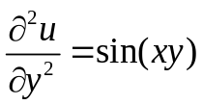 by direct integration method. | CO1 | (04)
 | c) | Find the number of men getting wages between Rs. 10 and Rs. 15 from the following data. | CO1 | (07)
  wages | 0 – 10 | 10 - 20 | 20 - 30 | 30 - 40
  No. of men | 9 | 30 | 35 | 42
 | d) | Given the data, find f(9) using the Newton’s divided difference formula. | CO1 | (07)
  x | 5 | 7 | 11 | 13 | 17
  f(x) | 150 | 392 | 1452 | 2366 | 5202
2. | a) | Write Lagrange’s interpolation formula. | CO1 | (02)
 | b) | The following table gives corresponding values of pressure p and specific volume v of a superheated steam. Find the rate of change of p with respect to v at v = 2. | CO1 | (04)
  V | 2 | 4 | 6 | 8 | 10
  P | 105 | 42.7 | 25.3 | 16.7 | 13
 | c) | Evaluate 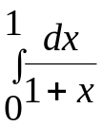 by using Simpson’s 3/8th rule taking 7 ordinates and  hence deduce an approximate value of log 2. | CO1 | (07)
 | d) | Solve the equation 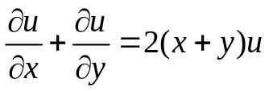 by method of separation of variables. | CO1 | (07)
 |  | UNIT- II
3. | a) | Define Mathematical expectation of the function φ(X) of the random variate X in both discrete and continuous cases. | CO2 | (02)
 | b) | The probability that a man aged 60 will live up to 70 is 0.65. What is the probability that out of 10 men, now aged 60, at least 7 will live up to 70. | CO2 | (04)
 | c) | The Probability density function of a random variable X is given by  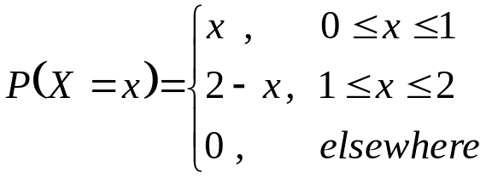.  Find (i) Cumulative Distribution Function F(X) and (ii) P(X ≥ 1.5). | CO2 | (07)
 | d) | In a normal distribution, 7% are under 35 and 89% are under 63. Find the mean and the standard deviation, given that A(1.23) = 0.39 and A(1.48) = 0.43 in the usual notation. | CO2 | (07)
4. | a) | Write probability density function of Uniform distribution. | CO2 | (02)
 | b) | The probability distribution of a random variable X is given by the following table  Find k and the mean. | CO2 | (04)
  X | 0 | 1 | 2 | 3 | 4 | 5
  P(X) | k | 5k | 10k | 10k | 5k | k
 | c) | In a certain factory turning out razor blades, there is a small chance of 0.002 for any blade to be defective. The blades are supplied in packets of 10, use Poisson distribution to calculate the approximate number of packets containing no defective, one defective and two defective blades respectively in a consignment of 10,000 packets. | CO2 | (07)
 | d) | The sales per day in a shop are exponentially distributed with average sale amounting to Rs.100 and net profit is 8%. Find the probability that the net profit exceeds Rs.30 on two consecutive days. | CO2 | (07)
 |  | UNIT- III
5. | a) | Write the expressions for autocorrelation, auto covariance and correlation coefficient. | CO3 | (02)
 | b) | A random process X(t) is represented by the ensemble {-k, -2k, -3k, k, 2k, 3k} (k > 0) corresponding to the outcomes of an event which are equally probable. Show that the random process is SSS. | CO3 | (04)
 | c) | If X and Y are continuous random variables having the joint density function,  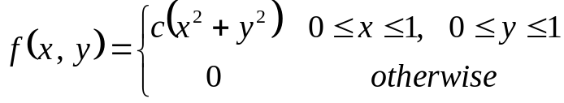  Find: (i) the value of (ii)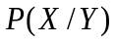 (iii)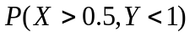 | CO3 | (07)
 | d) | A bag contains 3 white, 2 red and 2 green balls. 3 balls are selected at random. If X & Y are discrete random variables denoting number of white and red balls respectively. Determine (i) joint distribution of X and Y ;(ii) COV(X,Y). | CO3 | (07)
6. | a) | Classify the stochastic process. | CO3 | (02)
 | b) | Let X and Y be continuous random variables having the joint density function 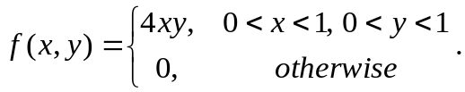 Find E(X). | CO3 | (04)
 | c) | The joint distribution table for two random variables X and Y is as follows :  (i) correlation of X and Y (ii) verify X and Y are dependent variables and (iii) find P(X+Y > 0). | CO3 | (07)
  Y  X | -2 | -1 | 4 | 5
  1 | 0.1 | 0.2 | 0 | 0.3
  2 | 0.2 | 0.1 | 0.1 | 0
 | d) | Find the auto correlation of the stochastic process defined by 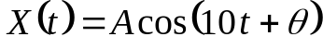, where is a random variable with mean 0 and variance 1 and is uniformly distributed in the interval 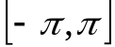. | CO3 | (07)
 |  | UNIT- IV
7. | a) | Define (i) Absorbing state (ii) Recurring state. | CO4 | (02)
 | b) | At a one man barber shop customers arrive according to poisson distribution with a mean arrival rate of 5/hr. The hair cutting time is exponential distribution with a hair cut taking 10 min on an average assuming that the customers are always willing to wait. Find (i) the average number of customers in the shop (ii) the average waiting time of a customer. | CO4 | (04)
 | c) | A salesman’s territory consists of three cities A, B & C. He never sells in the same city on successive days. If he sells in city A, then the next day he sells in city B. However, if he sells in either B or C, then the next day he is twice as likely to sell in city A as in other city. In the long run how often does he sell in each of the cities? | CO4 | (07)
 | d) | A xerox machine in an office is operated by a person who does other jobs also. The average service time for a job is 6 minutes per customer. On an average, every 12 minutes, customer arrives for xeroxing. Find (i) the xerox machine utilization (ii) the percentage of times that an arrival has not to wait (iii) the average time spent by a customer (iv) the average queue length (v) the arrival rate, if the management is willing to deploy the person exclusively for xeroxing when the average time spent by a customer exceeds 15 minutes. | CO4 | (07)
8. | a) | - Define M/M/1 queuing systems. | CO4 | (02)
 | b) | - Find the long run probability vector of:  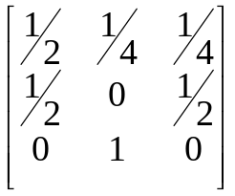 | CO4 | (04)
 | c) | - Two boys b₁ and b₂ and two girls g₁ and g₂ are throwing a ball from one to the other. Each boy throws the ball to the other with probability ½ and to each girl with probability ¼. On the other hand, each girl throws the ball to each boy with probability ½ and never to the girl. In the long run, how often does each receive the ball? | CO4 | (07)
 | d) | - Automatic car wash facility operates with only one boy. Car arrives according to a Poisson distribution, with a mean of 4 cars per hour and may wait in the facility’s parking lot if the boy is busy. If the service time for all cars is constant and equal to 10 minutes determine E(m), E(n), E(T) and E(w). | CO4 | (07)
 |  | UNIT- V
9. | a) | Define Degrees of Freedom. | CO5 | (02)
 | b) | A machinist is making engine parts with axle diameter of 0.7 inch. A random sample of 10 parts shows mean diameter 0.742 inch with a S.D. of 0.04inch .On the basis of the sample, would you say that the work is inferior? | CO5 | (04)
 | c) | Two independent samples of sizes 8 and 7 contain the following values:  Is the difference between the sample means significant? | CO5 | (07)
  Sample 1 | 19 | 17 | 15 | 21 | 16 | 18 | 16 | 14
  Sample 2 | 15 | 14 | 15 | 19 | 15 | 18 | 16
 | d) | The following table gives the number of train accidents in a country that occurred during the various days of the week. Find whether the accidents are uniformly distributed over the week. | CO5 | (07)
  Days | Sun | Mon | Tue | Wed | Thu | Fri | Sat
  No. of accidents | 20 | 18 | 13 | 23 | 26 | 11 | 15
10. | a) | Write the test statistic for Z-Test. | CO5 | (02)
 | b) | Two samples of sizes 9 and 8 gave the sums of squares of deviations from their respective means equal to 160 and 91 respectively. Can they be regarded as drawn from the same normal population? | CO5 | (04)
 | c) | The following data represents the biological values of protein from cow’s milk and buffalo’s milk at a certain level.  Examine if the average values of protein in the two samples significantly differ. | CO5 | (07)
  cow’s milk | 19 | 17 | 15 | 21 | 16 | 18 | 16 | 14
  buffalo’s milk | 15 | 14 | 15 | 19 | 15 | 18 | 16
 | d) | The life time of electric bulbs for a random sample of 10 from a large consignment gave the following table.  Can we accept the hypothesis that the average life time of bulbs is 4000 hours? | CO5 | (07)
  Item | 1 | 2 | 3 | 4 | 5 | 6 | 7 | 8 | 9 | 10
  Life in 1000 hrs | 1.2 | 4.6 | 3.9 | 4.1 | 5.2 | 3.8 | 3.9 | 4.3 | 4.4 | 5.6

****************

